ARAGEN LIFE SCIENCES

Lab Data Quality Monitor

Internship Technical Assignment

Submitted By:
Miya K

Technologies:
Python | Pandas | SQLite | Streamlit | Plotly | Docker

June 2026

Table of Contents

SL NO. | CONTENT | PAGE NO.
1. | Introduction | 3
2. | Project Architecture | 4
3. | Synthetic Dataset Generation | 7
4. | ETL Pipeline | 9
5. | Data Quality Rules Engine | 15
6. | Interactive Dashboard | 18
7. | Deployment | 21
8. | Bonus Implementation | 23
9. | Conclusion | 25

1. Introduction
Data quality is a critical requirement in pharmaceutical and life sciences organizations. Laboratory data generated from experiments, instruments, and quality control processes must be accurate, complete, consistent, and reliable to support scientific decision-making and regulatory compliance.
The objective of this assignment was to design and implement an end-to-end Data Quality Monitoring Solution capable of:
- Generating synthetic laboratory data
- Building an ETL pipeline
- Implementing data quality validation rules
- Calculating quality metrics and severity levels
- Visualizing insights through an interactive dashboard
The complete solution was developed using Python, Pandas, SQLite, and Streamlit.

2. Project Architecture
The solution follows a four-stage architecture:
- Dataset Generation
- ETL Pipeline
- Data Quality Rules Engine
- Interactive Dashboard
Data Flow:
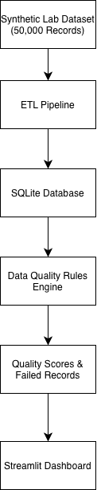
Fig 1: End-to-end project architecture

Technologies Used
Technology | Purpose
Python | Core development
Pandas | Data processing
Faker | Synthetic data generation
SQLite | Database storage
Streamlit | Dashboard development
Plotly | Interactive visualizations
Google Colab | Development environment
Docker | Containerization and local deployment
PyArrow | Parquet file format output

Tools Selection Justification

Tool | Justification
Python | Chosen as the primary programming language due to its extensive ecosystem for data engineering, analytics, and dashboard development.
Pandas | Provides powerful data manipulation, cleaning, transformation, and ETL capabilities.
Faker | Used to generate realistic synthetic laboratory records for testing and simulation purposes.
SQLite | Lightweight relational database requiring no server setup and easily integrated with Python for analytical processing.
Streamlit | Enables rapid creation of interactive dashboards without requiring frontend development expertise.
Plotly | Provides interactive charts and visual analytics suitable for exploratory data analysis and monitoring dashboards.
GitHub | Used for source code version control, project collaboration, and repository hosting.
Streamlit Community Cloud | Provides a simple and free deployment platform for sharing the dashboard online.
Docker | Packages the Streamlit dashboard and all dependencies into a portable container, ensuring consistent execution across different machines without environment configuration issues.
PyArrow | Enables writing processed data in columnar Parquet format with partition support, mirroring industry-standard data lakehouse storage patterns.

Repository Structure

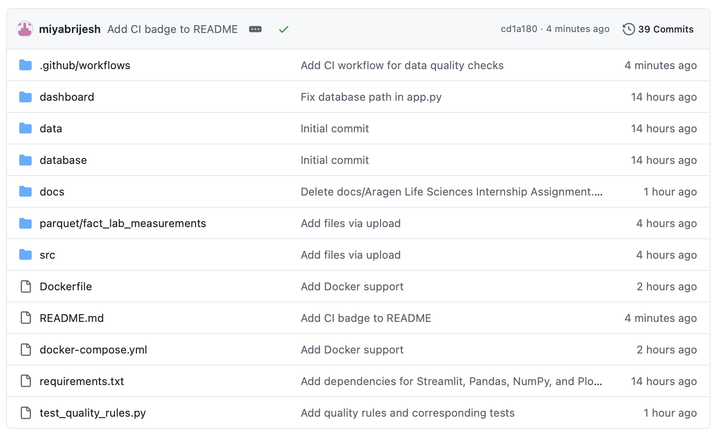

3. Task 1 – Synthetic Dataset Generation
A synthetic pharmaceutical laboratory dataset consisting of approximately 500,000 records was generated.
Each record represents a laboratory measurement collected during an experiment.

Dataset Fields
- sample_id
- lab_name
- instrument_name
- operator_name
- experiment_date
- recorded_at
- analyte_name
- measured_value
- unit
- status

Data Quality Issues Injected
To simulate real-world scenarios, multiple data quality issues were intentionally introduced into the dataset:

Missing Values
Random null values were inserted in important columns such as:
- measured_value
- unit

Duplicate Records
Duplicate sample IDs were introduced to test uniqueness validation.

Invalid Measurements
Invalid values such as:
- Negative measurements
- Values outside acceptable ranges
were inserted into the dataset.

Status Inconsistencies
Records containing logical inconsistencies between status and measurement values were created.

Stale Records
Records where recorded_at occurred significantly later than experiment_date were introduced.

Output
Generated Dataset:
lab_data.csv
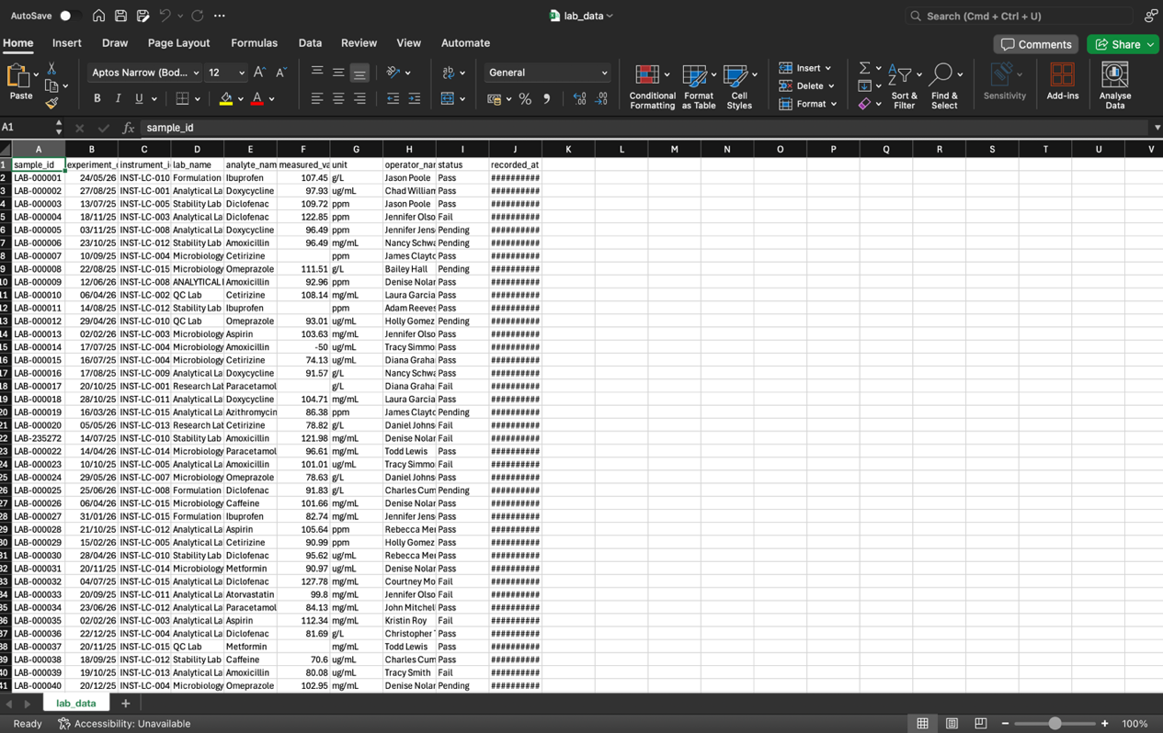

Dataset Availability
The synthetic dataset contains approximately 500,000 records and the generated SQLite database exceeds GitHub's recommended file size limits.

To keep the repository lightweight and maintainable, large data artifacts have been excluded from version control.

The repository contains:
• Source code
• ETL pipeline notebooks
• Dashboard implementation
• Documentation

The dashboard was developed and validated locally using the complete dataset and database.

4. Task 2 – ETL Pipeline
An ETL (Extract, Transform, Load) pipeline was implemented to process the generated laboratory data.

Extract
The pipeline reads data from the generated CSV dataset.
Input Source:
lab_data.csv
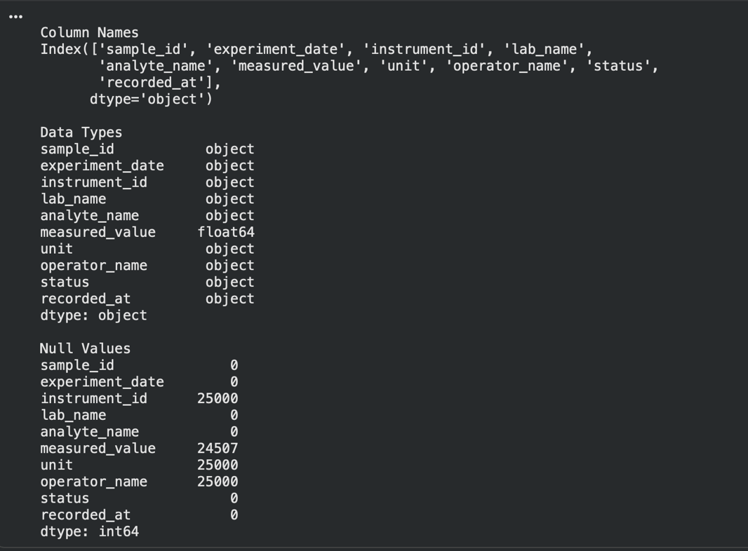

Transform
Several data cleaning and transformation operations were performed:

Data Cleaning
- Removed unwanted records
- Standardized date formats
- Handled missing values
- Converted data types

Validation
Basic validation checks were applied before loading.

Star Schema Design
A star schema was implemented to support analytical processing.

Fact Table
fact_lab_measurements
Contains:
- sample_id
- measured_value
- quality_score
- status
- foreign keys

Dimension Tables
dim_lab
dim_instrument
dim_operator
These tables contain descriptive information and support efficient reporting.

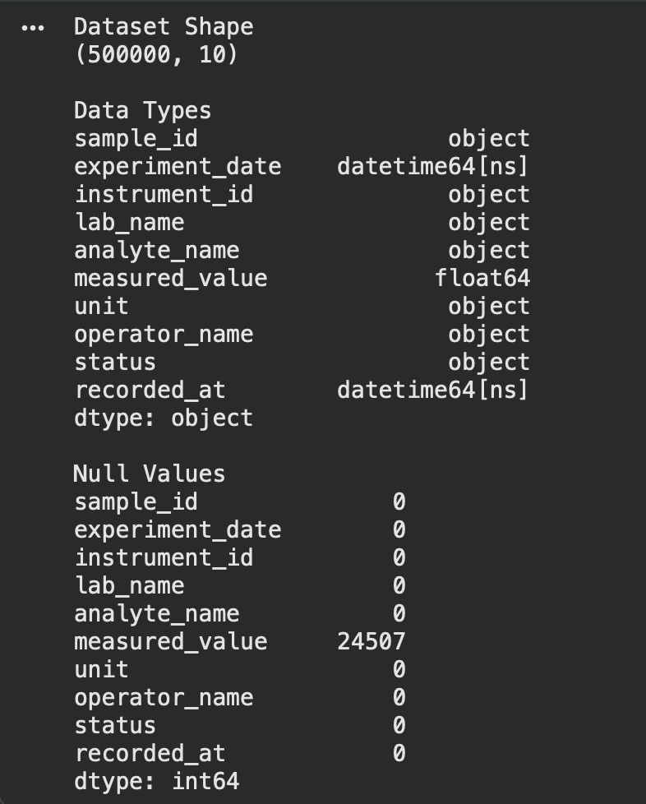

Load
The transformed data was loaded into SQLite.
Database:
lab_quality.db

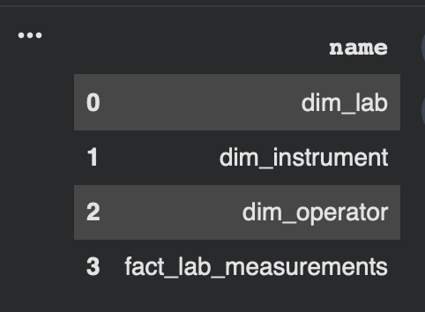

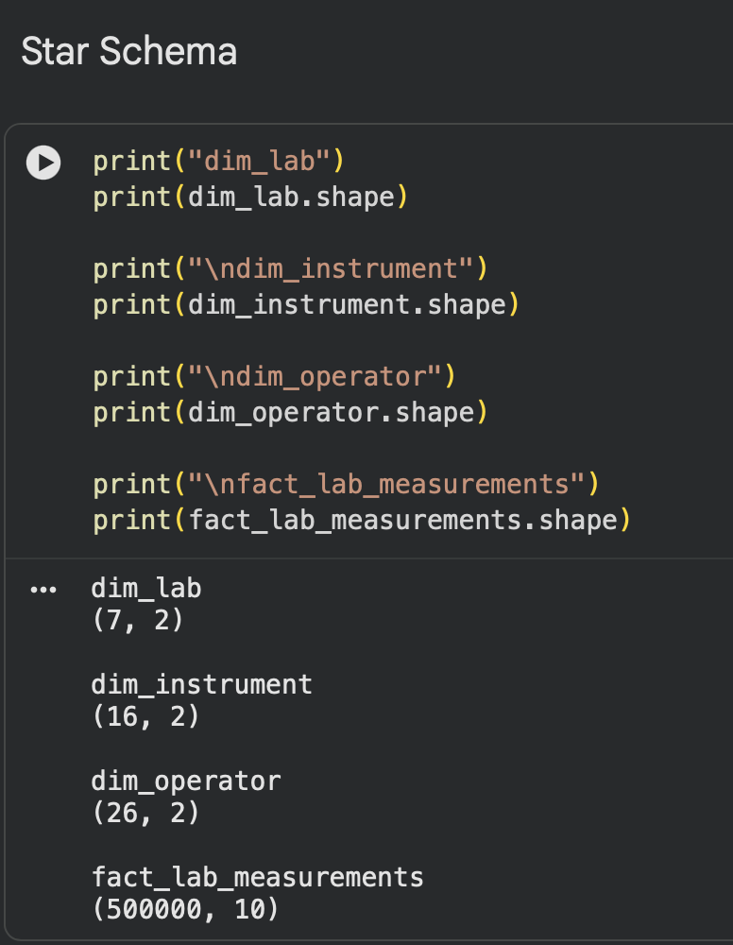
Tool Selection: Pandas vs PySpark
Pandas was selected over PySpark for the ETL pipeline based on the following analysis:
Factor | Pandas | PySpark
Dataset size | Efficient for datasets under 5M rows | Optimal for 10M+ rows across clusters
Setup complexity | Zero setup — runs in Colab | Requires JVM, Spark context, cluster config
Memory at 500K rows | ~150–200 MB, well within limits | Spark overhead exceeds data size at this scale
Development speed | Fast iteration in Jupyter notebooks | Verbose; DAG compilation adds overhead
Production readiness | Suitable for single-node pipelines | Required for distributed, multi-node ETL

At 500,000 rows, Pandas handles the full dataset comfortably on a single machine. PySpark's advantages — lazy evaluation, the Catalyst optimizer, distributed partitioning — only provide measurable benefit at significantly larger scales. Introducing PySpark here would add unnecessary infrastructure complexity with no performance gain.

Upgrade path: If this pipeline were to scale to 50M+ rows across multiple labs, PySpark with Parquet output on a cloud lakehouse (AWS S3 + Glue) would be the appropriate evolution.

Database Schema
The solution follows a star schema design to support analytical reporting and dashboard performance.

Fact Table
fact_lab_measurements
Stores laboratory measurement records and quality evaluation results.
Key columns:
- sample_id
- lab_key
- instrument_key
- operator_key
- measured_value
- quality_score
- severity

Dimension Tables
dim_lab
Contains laboratory information.
dim_instrument
Contains instrument information.
dim_operator
Contains operator information.

Failed Records Table
failed_records
Stores all records that violated one or more data quality rules and are used for dashboard drill-down analysis.

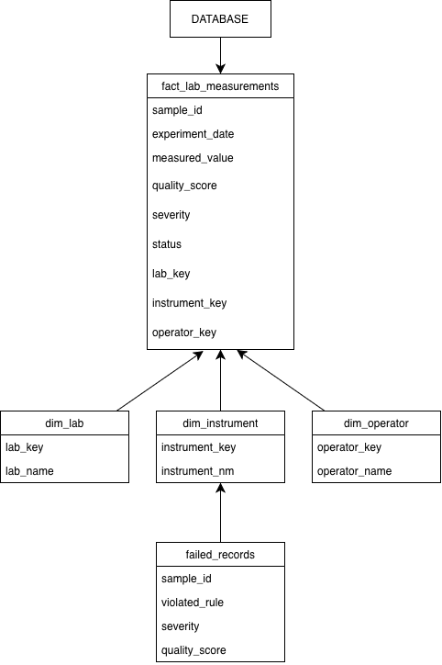

Data Dictionary
Field | Description
sample_id | Unique identifier for laboratory samples
lab_name | Laboratory where experiment was conducted
instrument_name | Instrument used for measurement
operator_name | Responsible operator
experiment_date | Date of experiment
recorded_at | Timestamp of record creation
measured_value | Recorded measurement value
unit | Measurement unit
status | Pass/Fail status
quality_score | Calculated data quality score

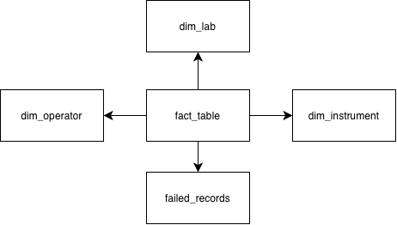

Fig 2: Database Schema Design

5. Task 3 – Data Quality Rules Engine
A rule-based Data Quality Engine was developed to evaluate every laboratory record.
The implementation covers five major quality dimensions:
- Completeness
- Uniqueness
- Validity
- Consistency
- Timeliness

Implemented Quality Rules

Completeness
- Rule 1:
measured_value should not be null
- Rule 2:
unit should not be null
- Rule 3:
status should not be null

Uniqueness
- Rule 4:
sample_id must be unique

Validity
- Rule 5:
measured_value must be greater than or equal to 0
- Rule 6:
measured_value must be less than or equal to 120
- Rule 7:
status must belong to valid status categories

Consistency
- Rule 8:
status = Pass should not have null measured_value
- Rule 9:
status = Fail should contain a measurement value
- Rule 10:
unit must belong to approved unit categories

Timeliness
- Rule 11:
recorded_at should not exceed experiment_date by more than 24 hours

Referential Integrity
- Rule 12:
foreign keys must map correctly to dimension tables

Quality Score Calculation
Each record receives a score between 0 and 100.

Formula:
Quality Score = (Number of Rules Passed ÷ Total Rules) × 100

Records passing all rules receive a score of 100.

Severity Classification
Failed records are categorized into:

Critical — Quality Score < 50
Major — Quality Score between 50 and 79
Minor — Quality Score ≥ 80

Results
Metric | Value
Records Generated | 500,000
Dimension Tables | 3
Fact Tables | 1
Quality Rules | 12
Dataset Quality Score | 97.15%
Failed Records | 95,838
Dashboard Filters | 4

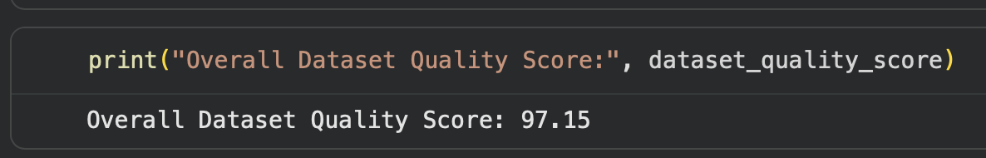

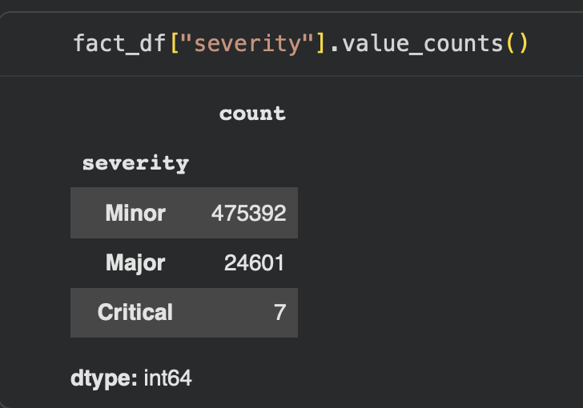

Rule ID | Rule Name | Description | Dimension | Severity | Threshold
R01 | Null Measurement | measured_value must not be null | Completeness | Major | 0 nulls
R02 | Null Unit | unit must not be null | Completeness | Major | 0 nulls
R03 | Null Status | status must not be null | Completeness | Minor | 0 nulls
R04 | Duplicate Sample ID | sample_id must be unique | Uniqueness | Major | 0 duplicates
R05 | Negative Measurement | measured_value ≥ 0 | Validity | Critical | min = 0
R06 | Out of Range Value | measured_value ≤ 120 | Validity | Critical | max = 120
R07 | Invalid Status | status in (Pass, Fail, Pending) | Validity | Minor | approved list
R08 | Pass with Null Value | status=Pass must have measured_value | Consistency | Major | no nulls on Pass
R09 | Fail with Null Value | status=Fail must have measured_value | Consistency | Major | no nulls on Fail
R10 | Invalid Unit | unit in approved unit list | Consistency | Minor | approved list
R11 | Stale Timestamp | recorded_at within 24hrs of experiment_date | Timeliness | Major | ≤ 24 hours
R12 | Referential Integrity | foreign keys map to dimension tables | Referential Integrity | Critical | 0 orphans

6. Task 4 – Interactive Dashboard
An interactive dashboard was developed using Streamlit to provide real-time visibility into laboratory data quality.
The dashboard reads data directly from the SQLite database generated in Task 3.

Features Implemented

KPI Cards
Displays:
- Overall Quality Score
- Total Records
- Failed Records

Quality Breakdown by Lab
Provides average quality score for each laboratory.

Quality Breakdown by Instrument
Highlights instrument-wise quality performance.

Quality Score Over Time
Visualizes trends across experiment dates.

Severity Distribution
Displays:
- Critical
- Major
- Minor
failure proportions.

Failed Records Drilldown
Interactive table showing records that failed validation checks.

Dashboard Filters
The following filters were implemented:
- Severity
- Lab
- Instrument
- Date Range
These filters allow users to perform targeted quality investigations.
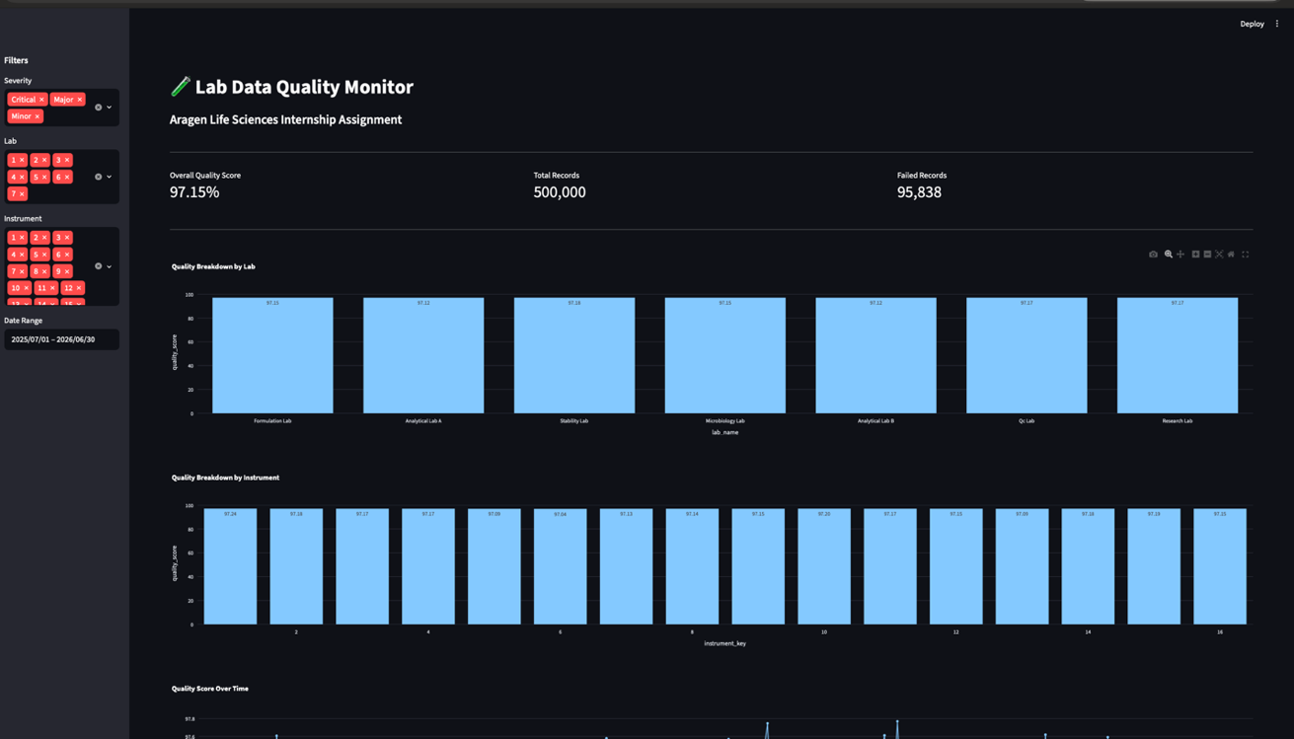
Fig 3: Dashboard Overview

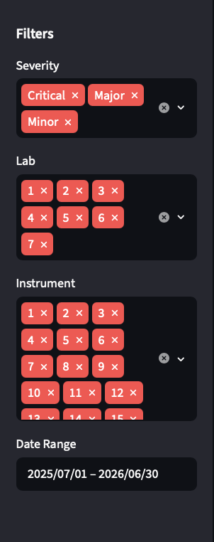

Fig 3: Dashboard Filters

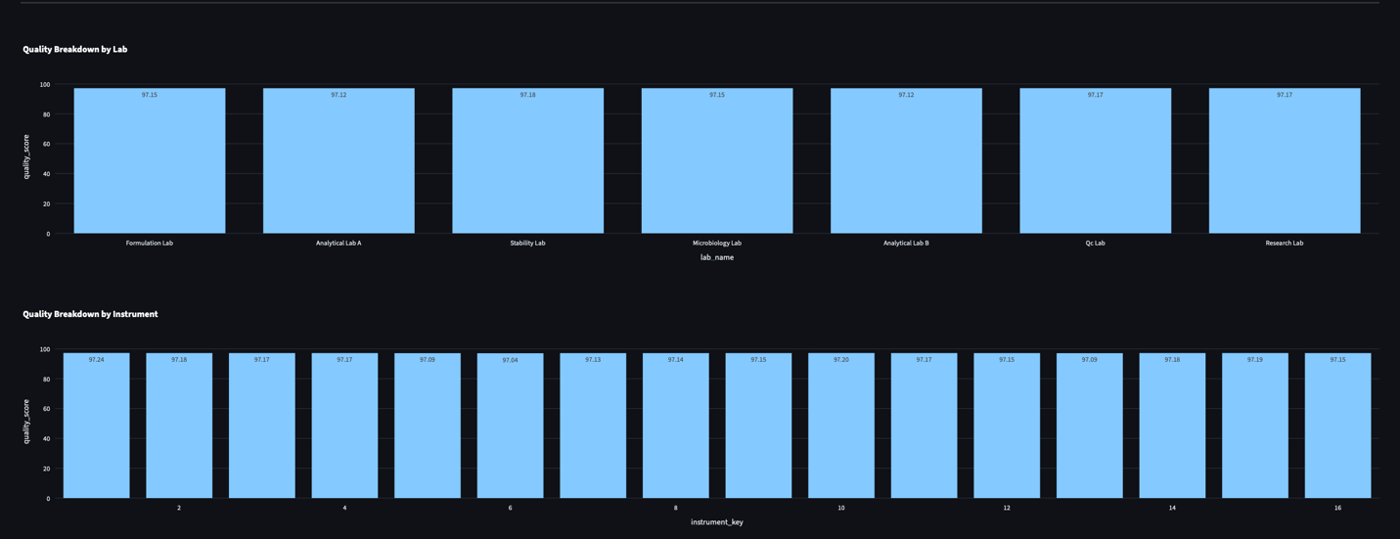

Fig 4: Quality Breakdown Analytics

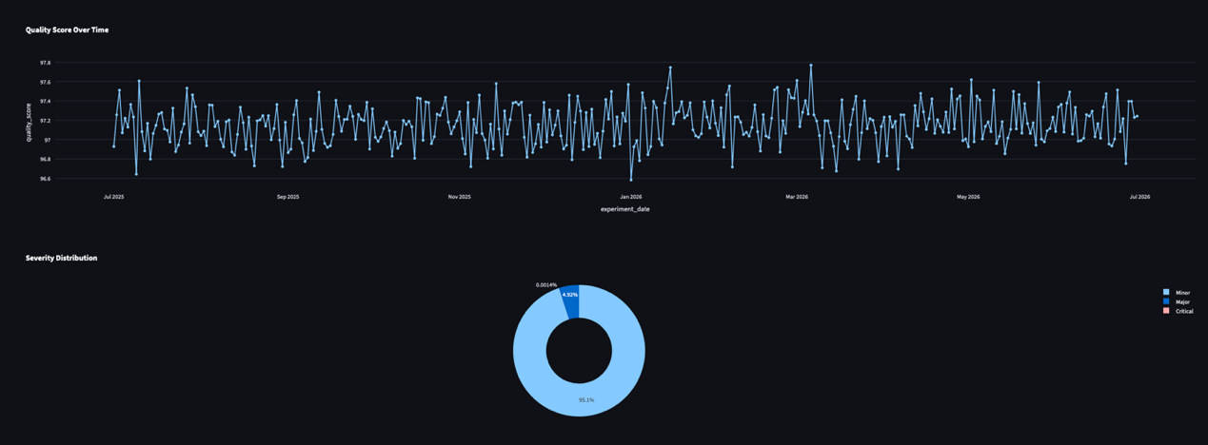

Fig 5: Trend and Severity Analytics

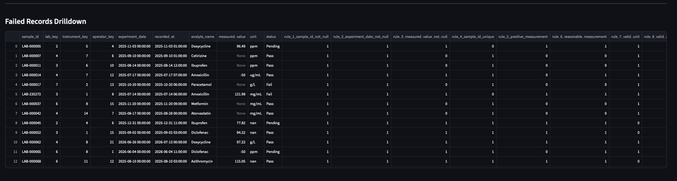

Fig 6: Failed Records Drilldown

Deployment
The dashboard was deployed using Streamlit Community Cloud.

GitHub Repository
https://github.com/miyabrijesh/aragen-lab-data-quality-monitor

Live Dashboard
https://aragen-lab-data-quality-monitor-ephu6jrh58bpnng2zjus3n.streamlit.app

Key Learnings
- Developed an end-to-end ETL pipeline using Python and Pandas.
- Implemented automated data quality validation rules.
- Designed a star schema database for analytical reporting.
- Built an interactive dashboard using Streamlit and Plotly.
- Gained experience in data quality monitoring and reporting workflows.
- Deployed a data application using Streamlit Community Cloud.
- Implemented Parquet partitioned output following Data Lakehouse storage patterns.
- Containerized the application using Docker for portable and reproducible deployment.

7. Bonus Implementations
7.1 Parquet Partitioned Output
The processed fact table was exported in Apache Parquet format, partitioned by laboratory name, as a bonus enhancement to mirror real-world Data Lakehouse patterns.
Partition structure:
parquet/
└── fact_lab_measurements/
├── lab_name=Analytical Lab A/
├── lab_name=Analytical Lab B/
├── lab_name=Formulation Lab/
├── lab_name=Microbiology Lab/
├── lab_name=QC Lab/
├── lab_name=Research Lab/
└── lab_name=Stability Lab/
Benefits:
- Faster analytical queries through partition pruning
- Reduced storage footprint compared to CSV
- Scalable design for cloud storage (S3, ADLS, GCS)
- Industry-standard format for data engineering pipelines
7.2 Docker Containerization
The Streamlit dashboard was containerized using Docker, enabling consistent and reproducible deployment across different environments.
Files added:
- Dockerfile — defines the Python 3.11 environment and runs the Streamlit app
- docker-compose.yml — mounts the database volume and exposes port 8501
To run locally:
docker-compose up --build
Dashboard accessible at: http://localhost:8501
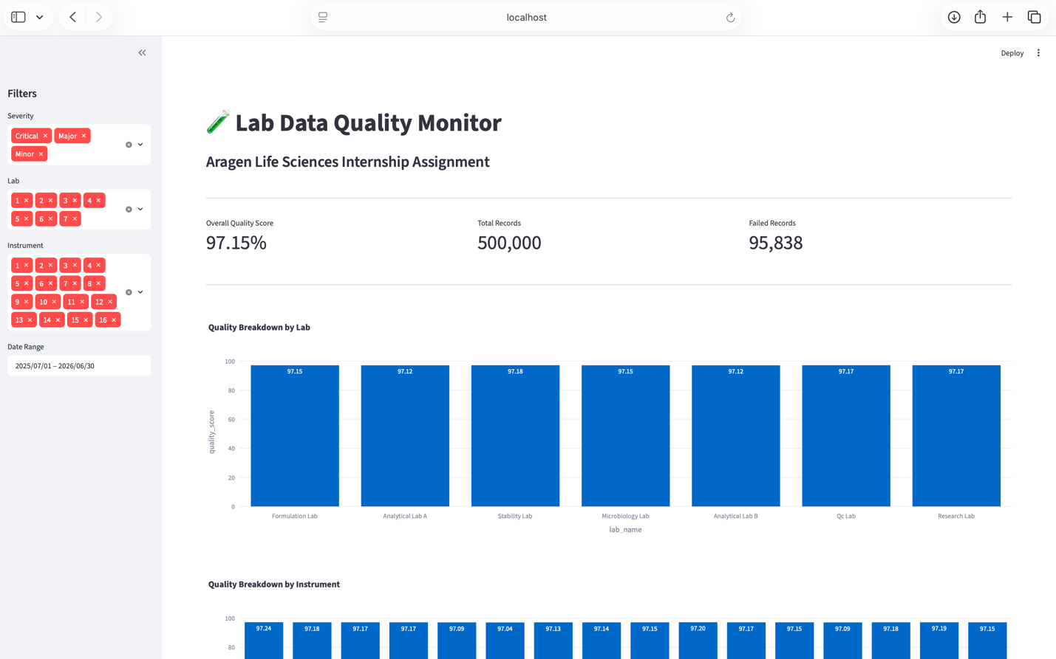

7.3 Unit Tests
13 automated unit tests written using pytest covering all 12 data quality rules. Tests validate correct pass/fail behavior for each rule including null checks, range violations, duplicate detection, and stale timestamps.
7.4 CI/CD Pipeline
GitHub Actions workflow (.github/workflows/ci.yml) automatically runs all unit tests on every push to main. Badge visible on README showing current build status — currently passing.

8. Conclusion
This project successfully demonstrates the implementation of an end-to-end Data Quality Monitoring Platform for laboratory data.
The solution includes:
- Synthetic data generation
- ETL processing pipeline
- Star schema database design
- Automated data quality rule engine
- Quality scoring framework
- Interactive monitoring dashboard
- Parquet partitioned output (Data Lakehouse pattern)
- Docker containerization for portable deployment
The final system achieved an overall dataset quality score of 97.15% and provides a scalable foundation for monitoring laboratory data quality in pharmaceutical and life sciences environments.
The project demonstrates practical knowledge of data engineering, data quality management, analytical modeling, and dashboard development, which are essential skills for modern data-driven organizations.

